Attention 3rd, 4th, and 5th Grade Parents

We have wonderful news and can’t wait to tell you about it! The STAAR test will be taken online again this year and the following information is sure to be of GREAT benefit to your child!!!

The Texas Education Agency allows students to showcase their mastery of the Texas Essential Knowledge and Skills (TEKS) in a way that suits them best, particularly through electronic platforms they already use at school and home. To help your child prepare for the upcoming assessment, visit the Texas Assessment website ([https://www.texasassessment.gov](https://www.texasassessment.gov/)) to explore the testing platform and complete a practice test to familiarize them with the different question formats.

To get started, just click on the *Students and Families* tab from the top menu bar:



Then scroll down to the *How to Help Prepare Your Child* Section and click on the *Practice Tests Login*:

When this screen appears, just click *Sign In* (no need to change any of the settings):

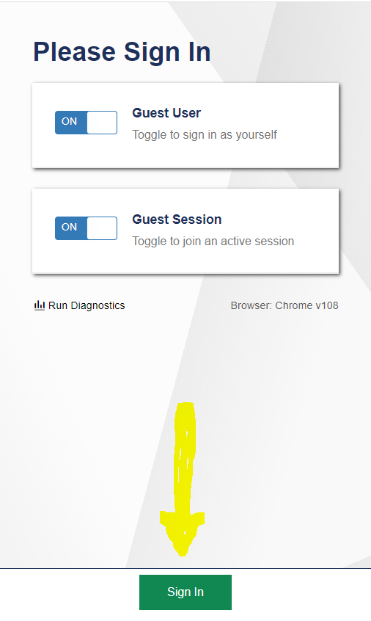

Select your child’s grade level using the dropdown menu arrows:

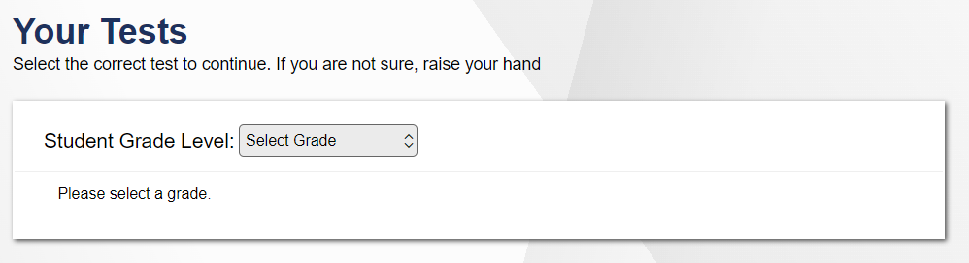

You’ll see the following screen to help you start exploring:

Your child has been working with similar question types on the assessments that we’ve been taking at school and should be able to help you navigate the practice tests when you’re exploring them together.

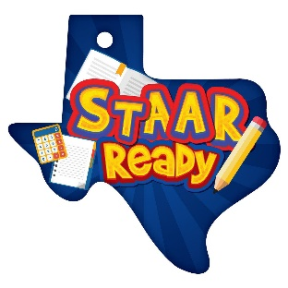  
To help prepare for the upcoming STAAR assessments in April, please discuss snack options with your child. Students will receive a coffee filter to place their snack on during testing, so it should fit neatly without creating a mess. Avoid snacks with liquids or sticky ingredients. Acceptable options include goldfish, teddy grahams, and pretzels. Please do NOT send candy, Cheetos, Takis, fruit cups, or similar items.

Thank you for partnering with us to help ensure all of our Cheetahs are STAAR Ready!